Father James A. Donnelly Council #11782
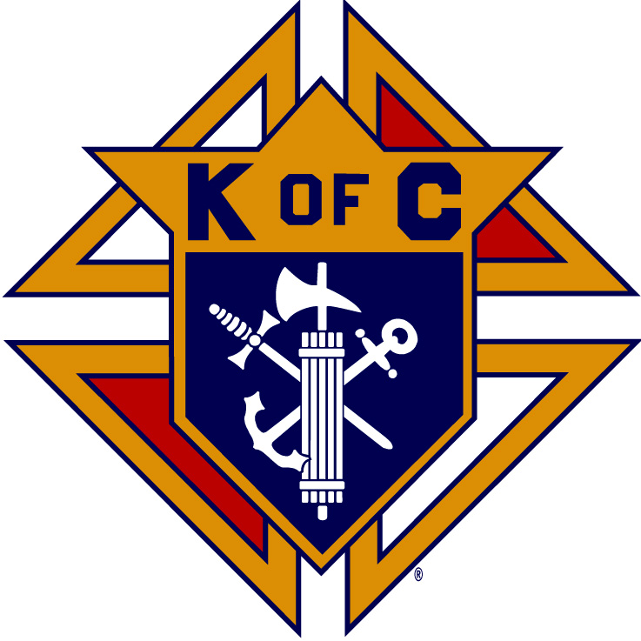

Knights of Columbus - Aston, Pa.

TO: 2025 High School Graduates

Planning to continue your education

As a full-time student at an institution

Of higher education

April 23rd, 2025

We are pleased to announce the 25th annual Colleen Betzal Memorial Scholarship. The scholarship is to be awarded to a student who has demonstrated a concern for community through volunteerism. The student should also be academically worthy and planning to attend an institution of higher learning as a fulltime student after graduation. The student must also be a resident of Aston Township or a member of the Church of Saint Joseph’s Parish (Aston, Pa). The minimum amount of the scholarship will be $2,500.00.

To date there have been 48 scholarships totaling $100,000 awarded to students from area high schools.

Each high school is limited to three (3) applicants. You are asked to forward all letters, transcripts, and applications together in one packet postmarked no later than May 19th, 2025. No applications will be accepted after this date.

Should you have any questions in the meantime, you may contact me at (h) 610-494-5168. Please direct all mailings to:

Colleen Betzal Memorial Scholarship
c/o Jim Grugan
133 Brakel Lane
Media, PA 19063

Sincerely,

Jim Grugan
Scholarship Committee

